Prtf 3 [Historical homicides Upaluk]

Name: Upaluk

Date:20/03/26

URL to Github code (where is your finished script):

This is the link to the folder for week 12 homework:

https://github.com/Digital-Methods-HASS/au737736_Hendriksen_Upaluk/tree/main/HomicideHistory_Upaluk

This is the link to the html version:

https://github.com/Digital-Methods-HASS/au737736_Hendriksen_Upaluk/blob/main/HomicideHistory_Upaluk/EuropeanHomicide_exercise.html

Visualisation: (include a legible and meaningful graphic with clear labels and no scientific notation)
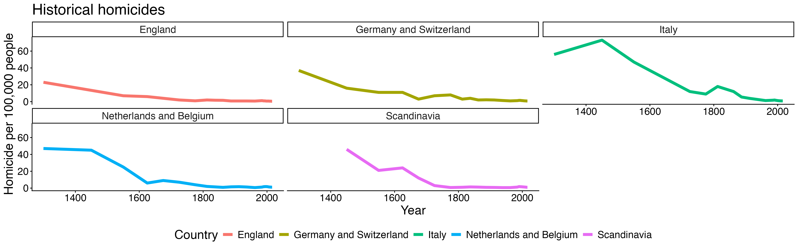
Significance: Explain what your visualisation represents and what are its implications vis-a-vis your [historical] research question (250 words)? Also, consider briefly what your visual does not show.
The visualisations show a clear, long-term decline in homicide rates across all regions from the medieval period to the present. In places like England, Italy, and the Netherlands/Belgium, rates fall dramatically from very high levels (often above 40–60 per 100,000) to near zero today. This suggests a substantial reduction in interpersonal violence over time.
On this basis, one could argue that societies have become more “civilized,” if civilization is associated with greater self-control, stronger legal institutions, and reduced tolerance for violence. The consistency of the downward trend across multiple regions strengthens this interpretation, pointing to broad structural changes such as the development of states, policing, and cultural norms discouraging violence.
However, the data only capture one dimension of “civilization”—homicide. They do not account for other forms of harm, such as war, structural inequality, or non-lethal violence. It is also possible that improvements in record-keeping affect earlier estimates.
Overall, the charts provide strong evidence that deadly interpersonal violence has decreased significantly over time, supporting the argument that, in this specific sense, we are more civilized today.

